**Analysis of a simple Bayesian network example**

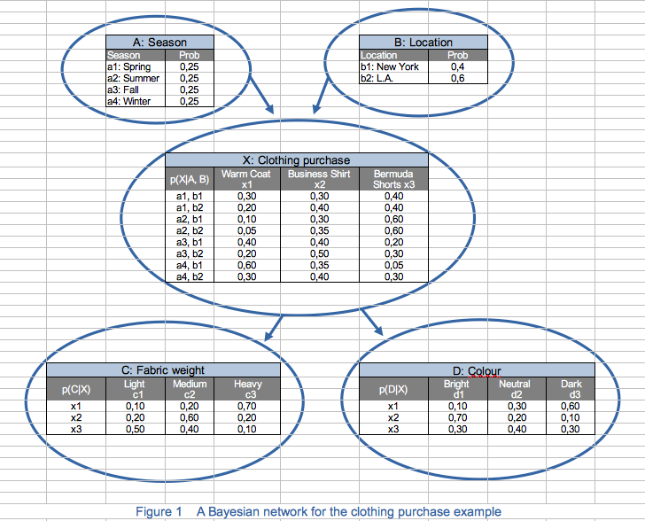

**1. Understanding the Bayesian Network Structure**

The network describes factors that influence clothing purchases, represented by the random variable X with three categories: Warm Coat (x1​), Business Shirt (x2​), and Bermuda Shorts (x3​).

The network consists of five nodes:

* **A: Season** (with values Spring, Summer, Fall, and Winter)
* **B: Location** (New York or Los Angeles)
* **X: Clothing Purchase** (Warm Coat, Business Shirt, or Bermuda Shorts)
* **C: Fabric Weight** (Light, Medium, or Heavy)
* **D: Color** (Bright, Neutral, or Dark)

These nodes interact as follows:

* **A** and **B** directly influence **X** (the type of clothing purchased).
* **X** directly influences **C** and **D** (fabric weight and color of the clothing).

The probabilities provided are conditional and represent the dependencies between these variables. For example:

* The table in the center shows p(X∣A $∩$ B), the probability distribution of clothing choices given the season and location.
* The tables below show p(C∣X) and p(D∣X), the probabilities of fabric weight and color given the type of clothing purchased.

**2. Key Probabilities in the Network**

**Prior Probabilities**

* **Season (A):** Each season has a probability of 0.25, indicating equal likelihood.
* **Location (B):** The probabilities are 0.4 for New York and 0.6 for Los Angeles.

**Conditional Probabilities**

1. **Clothing Purchase (X) given Season and Location (A and B):**
   * The table p(X∣A $∩$ B) provides the probabilities for each clothing item given the combination of season and location. For example, p(x1∣a1b1) = 0.30 is the probability of purchasing a Warm Coat in Spring in New York.
2. **Fabric Weight (C) given Clothing Type (X):**
   * p(C∣X) is the probability of choosing a certain fabric weight based on the type of clothing. For example, for Warm Coats (x1​), there’s a 10% chance of choosing a light fabric, a 20% chance for medium, and a 70% chance for heavy.
3. **Color (D) given Clothing Type (X):**
   * p(D∣X) gives the color probabilities for each type of clothing. For instance, a Business Shirt (x2) has a 70% chance of being bright, 20% neutral, and 10% dark.

**3. Conditional Independence in the Network**

Here are a few key relationships:

* **A and B are independent** since their probabilities don’t depend on each other.
* **C and D are conditionally independent given X** because knowing the type of clothing purchased (X) fully explains the choice of fabric weight and color, making C and D independent of each other.

**4. Calculations**

To understand how the probabilities propagate through the network, we can calculate joint and marginal probabilities.

**Example: Calculating a Joint Probability**

Let’s calculate the probability of purchasing a warm coat with a heavy fabric and a bright color in spring in New York.

1. **Choose the probability for Season (A) and Location (B):**
   * p(a1) = 0.25
   * p(b1) = 0.4
2. **Select the probability of purchasing a warm coat given the season and the location (A = spring and B = New York):**
   * p(x1∣a1b1) = 0.30
3. **Probability of a heavy fabric given clothing type (X = warm coat):**
   * p(c3∣x1) = 0.70
4. **Probability of a bright color given clothing type (X = warm coat):**
   * p(d1∣x1) = 0.10

We can now calculate the probability:p(a1,b1,x1,c3,d1) = p(a1)⋅p(b1)⋅p(x1∣a1b1)⋅p(c3∣x1)⋅p(d1∣x1) = 0.250.40.30.70.1   
p(a1b1x1c3d1) = 0.0021  
So, the joint probability of purchasing a bright, heavy warm coat in spring in New York is 0.0021.

**~~Marginal~~ Prior Probability of Warm Coat**

To find the probability of buying a warm coat (X = x1) across all seasons and locations, we have to sum over all possible combinations of A and B:

P(X = x1) = x1|ab)p(ab).

Since the Season (A) and the Location (B) are independent events, the probability

p(a $∩$ b) = p(a) $∙$ p(b). Therefore,

P(X = x1) = x1|ab)p(a)p(b)   
P(X = x1) = p(x1|a1b1)p(a1)p(b1) + p(x1|a1b2)p(a1)p(b2) + p(x1|a2b1)p(a2)p(b1) + p(x1|a2b2)p(a2)p(b2) + p(x1|a3b1)p(a3)p(b1) + p(x1|a3b2)p(a3)p(b2) + p(x1|a4b1)p(a4)p(b1) + p(x1|a4b2)p(a4)p(b2)   
P(X = x1) = 0.30.250.4 + 0.2 $∙$ 0.25 $∙$ 0.6 + 0.1 $∙$ 0.25 $∙$ 0.4 + 0.05 $∙$ 0.25 $∙$ 0.6 + 0.4 $∙$ 0.25 $∙$ 0.4 + 0.2 $∙$ 0.25 $∙$ 0.6 + 0.6 $∙$ 0.25 $∙$ 0.4 + 0.3 $∙$ 0.250.6   
P(X = x1) = 0.2525

Let’s say we observed that Fabric weight was light (C=c1) and we wanted to calculate the probability of the colour being Dark (D=d3).What we want to calculate is :

P(D=d3|C=c1)= $\frac{p\left(D=d3∩C=c1\right)}{p\left(C=c1\right)}$.

For the nominator we have

P(D=d3 $∩$ C=c1)= $\sum_{X=x}{P\left(D=d3∩C=c1 | X=x\right)∗P\left(X=x\right)=}$

C,D are independent given X

= $\sum_{X=x}{P\left(D=d3 | X=x\right)∗P\left(C=c1 | X=x\right)∗P\left(X=x\right)=}$

= $P\left(D=d3 | X=x1\right)∗P\left(C=c1 | X=x1\right)∗P\left(X=x1\right)$ $+P\left(D=d3 | X=x2\right)∗P\left(C=c1 | X=x2\right)∗P\left(X=x2\right)$ $+P\left(D=d3 | X=x3\right)∗P\left(C=c1 | X=x3\right)∗P\left(X=x3\right)$.(1)

We now compute

P(X=x2)=P(X=x2|A=a1,B=b1)*P(A=a1)*P(B=b1)+

P(X=x2|A=a1,B=b2)*P(A=a1)*P(B=b2)+

P(X=x2|A=a2,B=b1)*P(A=a2)*P(B=b1)+

P(X=x2|A=a2,B=b2)*P(A=a2)*P(B=b2)+

P(X=x2|A=a3,B=b1)*P(A=a3)*P(B=b1)+

P(X=x2|A=a3,B=b2)*P(A=a3)*P(B=b2)+

P(X=x2|A=a4,B=b1)*P(A=a4)*P(B=b1)+

P(X=x2|A=a4,B=b2)*P(A=a4)*P(B=b2)=

= 0.3*0.25*0.4 + 0.4*0.25*0.4 + 0.3*0.25*0.4 + 0.35*0.25*0.6 + 0.4*0.25*0.4 + 0.5*0.25*0.6 + 0.35*0.25*0.4 + 0.4*0.25*0.6 = 0.3825

In the similar fashion P(X=x3)=0.365 .(And P(X=x1)= 0.2525 from above)

Plugging these values into (1) along with the values of the corresponding CPT table we get:

(1)=0.6*0.1*0.2525+0.1*0.2*0.38+0.3*0.5*0.365 = 0.077

For the denominator we need to compute

P(C=c1)=P( C=c1|X=x1)P(X=x1) +P(C=c1|X=x2)P(X=x2) +P(C=c1|X=x3)P(X=x3)=0.1*0.2525+0.2*0.38+0.5*0.365=0.283

So P(D=d3|C=c1)= $\frac{p\left(D=d3∩C=c1\right)}{p\left(C=c1\right)}$ = $\frac{0.077}{0.283}$ =0.272

**5. Reference**  
Larose, D. T., & Larose, C. D. (2015). Data mining and predictive analytics (2nd ed., Chapter 14.11). Wiley.